**DeepLab report**

Caffe implementation: Issues w/ CUDNN 9

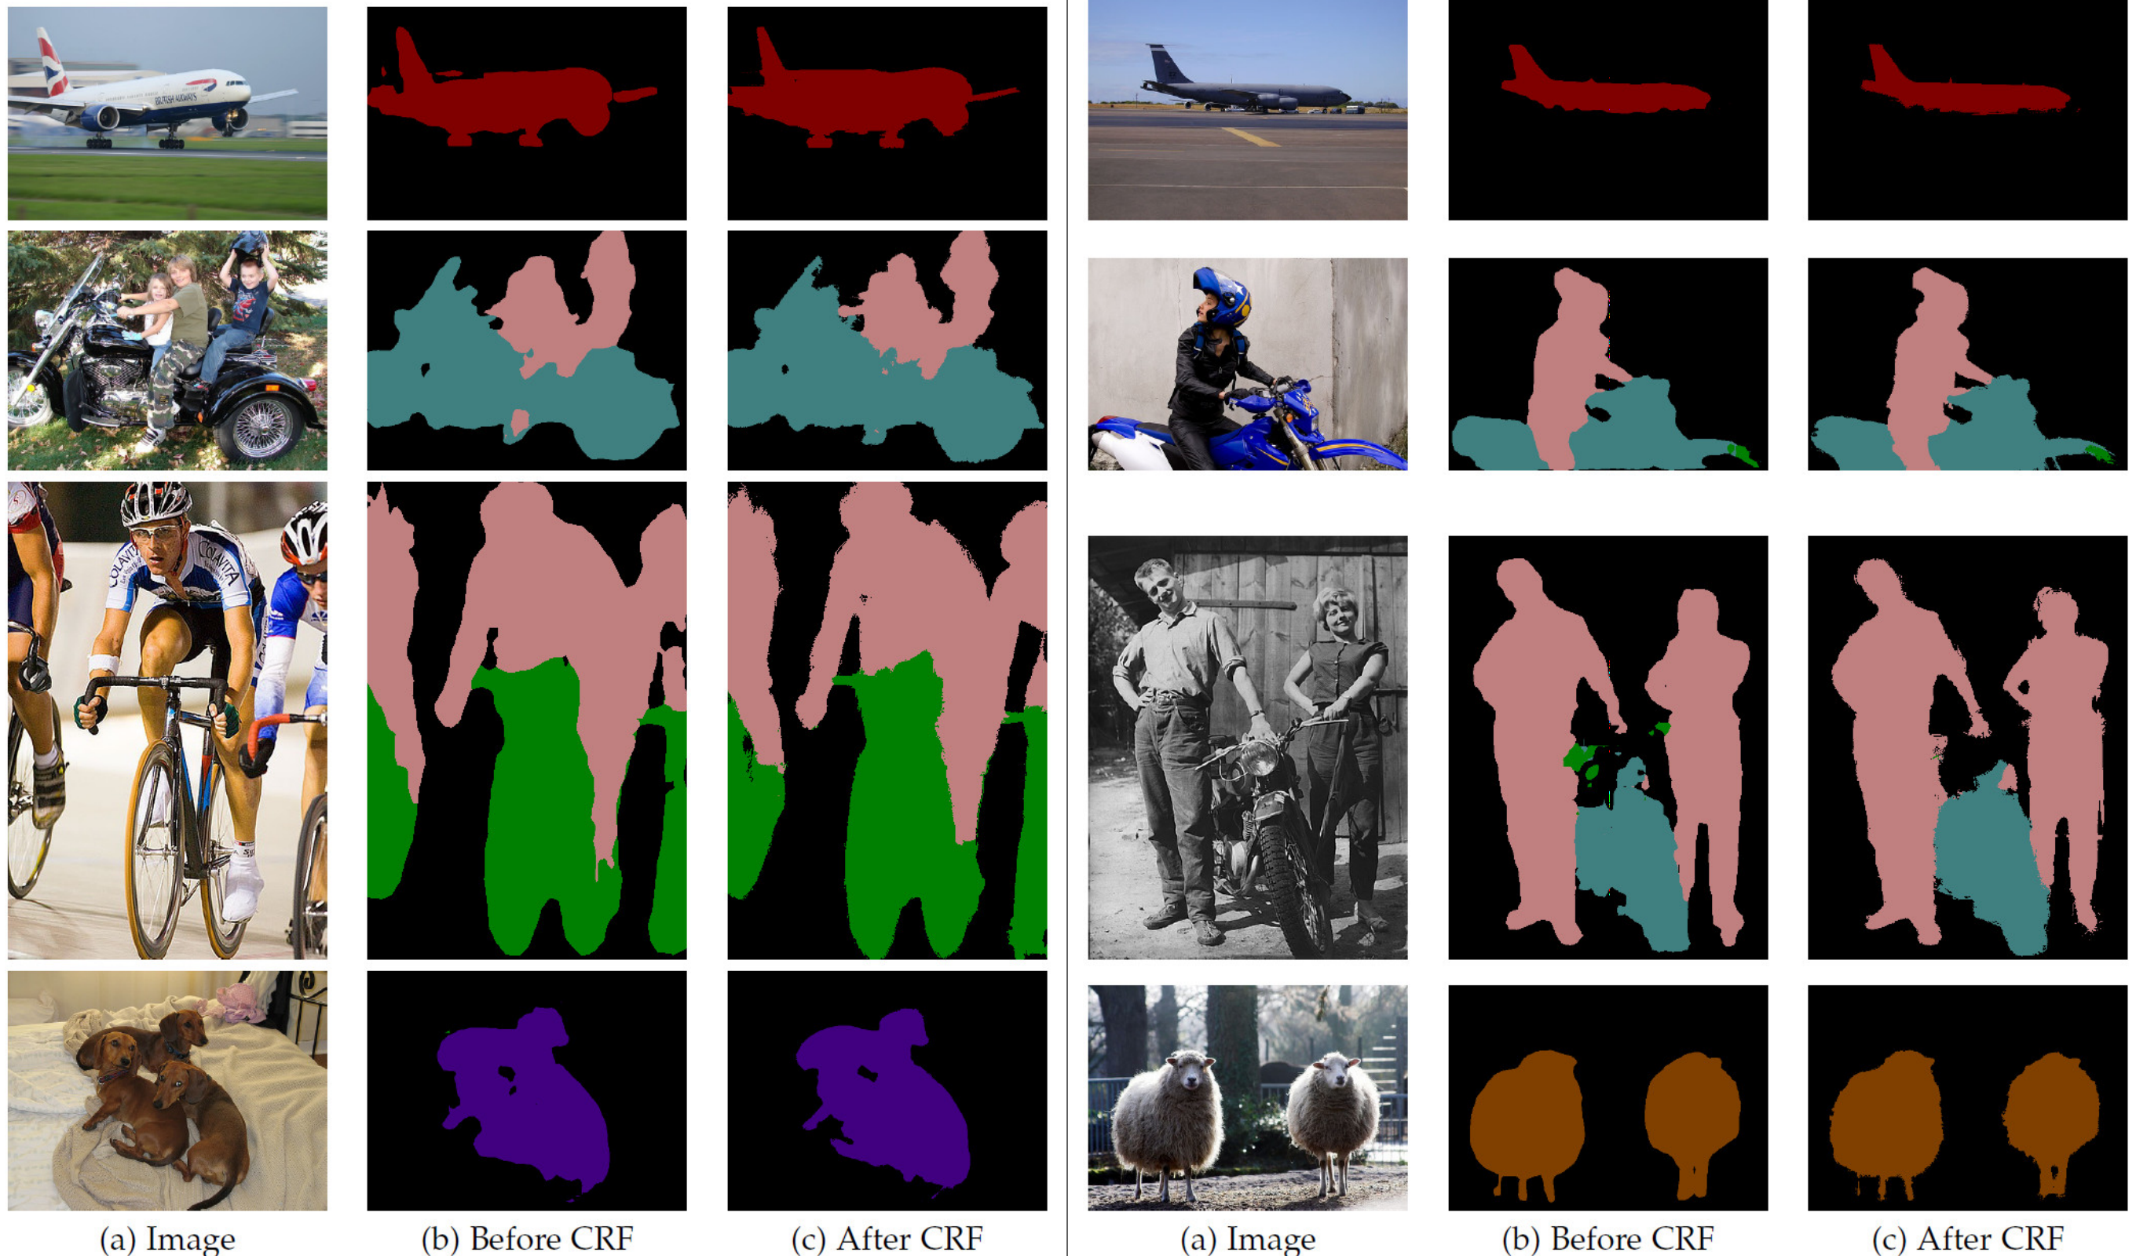

TensorFlow

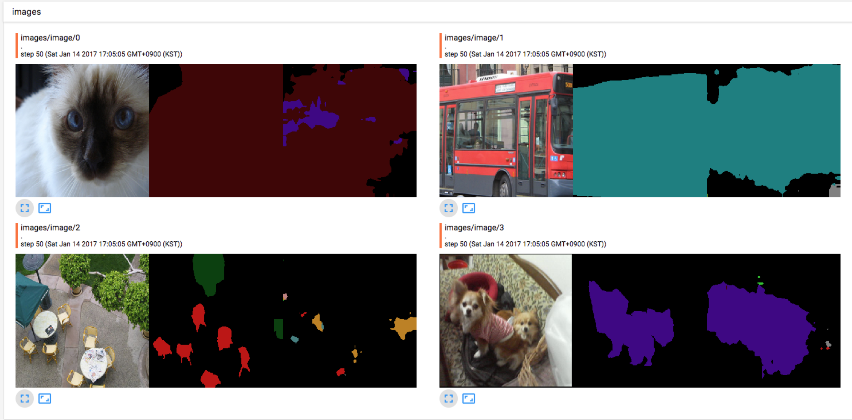

Instance Aware Segmentation:

* Mask-RCNN

